Hosting a Static Website Theory (1 hour): Overview of web hosting with Apache/Nginx. File placement and basic configurations for static sites.Practical (1 hour): Host a simple HTML page on the web server. Task: Customize and host a static webpage.

Tasks

1. Install Apache or Nginx on your Linux server and verify the installation by accessing the default web page via your browser.

ANS:

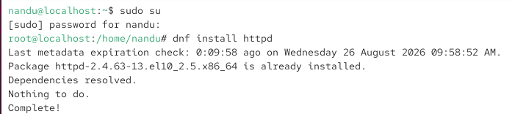

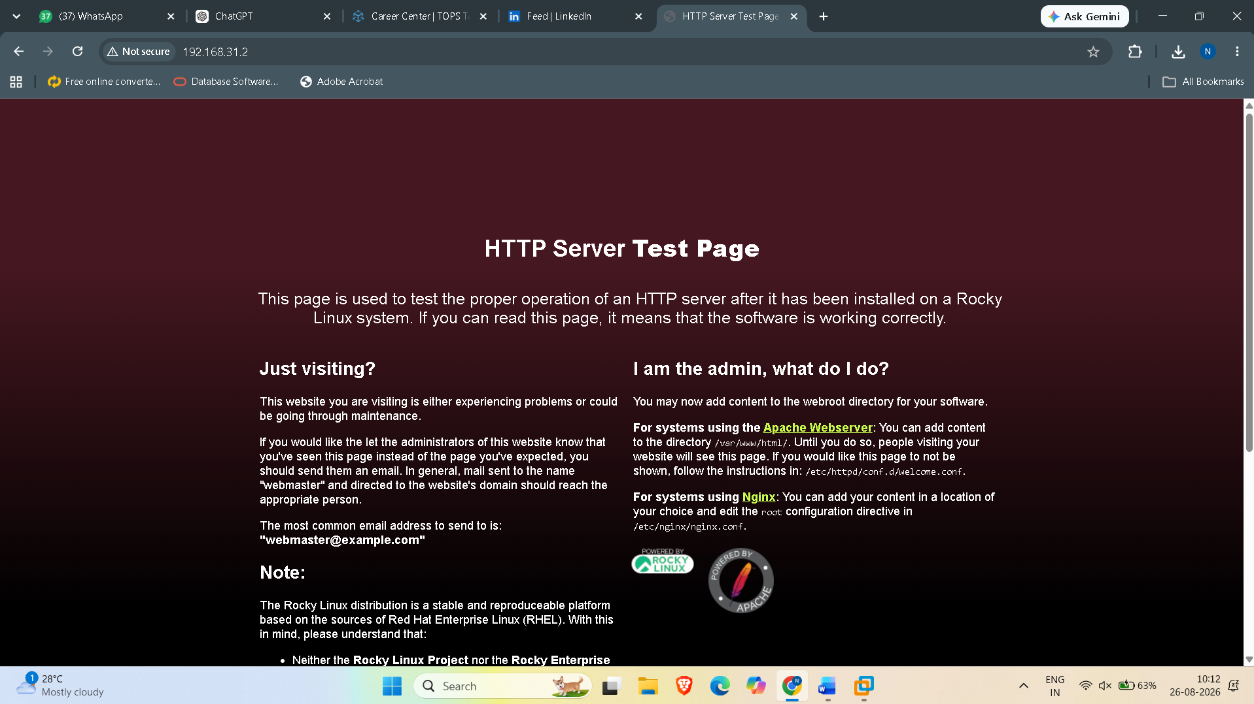

2. Create a folder named myflipkart in your web server's root directory and place an index.html file inside it that displays 'Welcome to MyFlipkart Deals!'.

ANS:

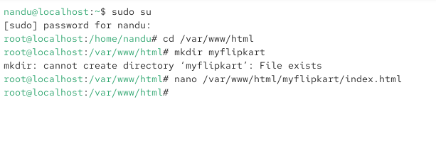

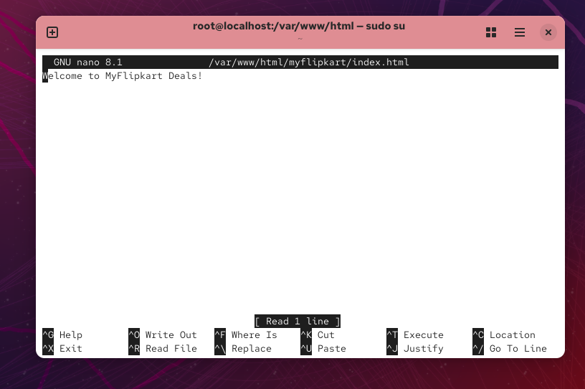

3. Update your web server configuration so that visiting http://localhost/myflipkart shows your custom index.html page instead of the default server page. For Apache, use the Alias directive; for Nginx, use a new location block.

ANS:

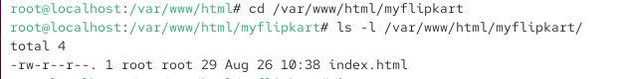

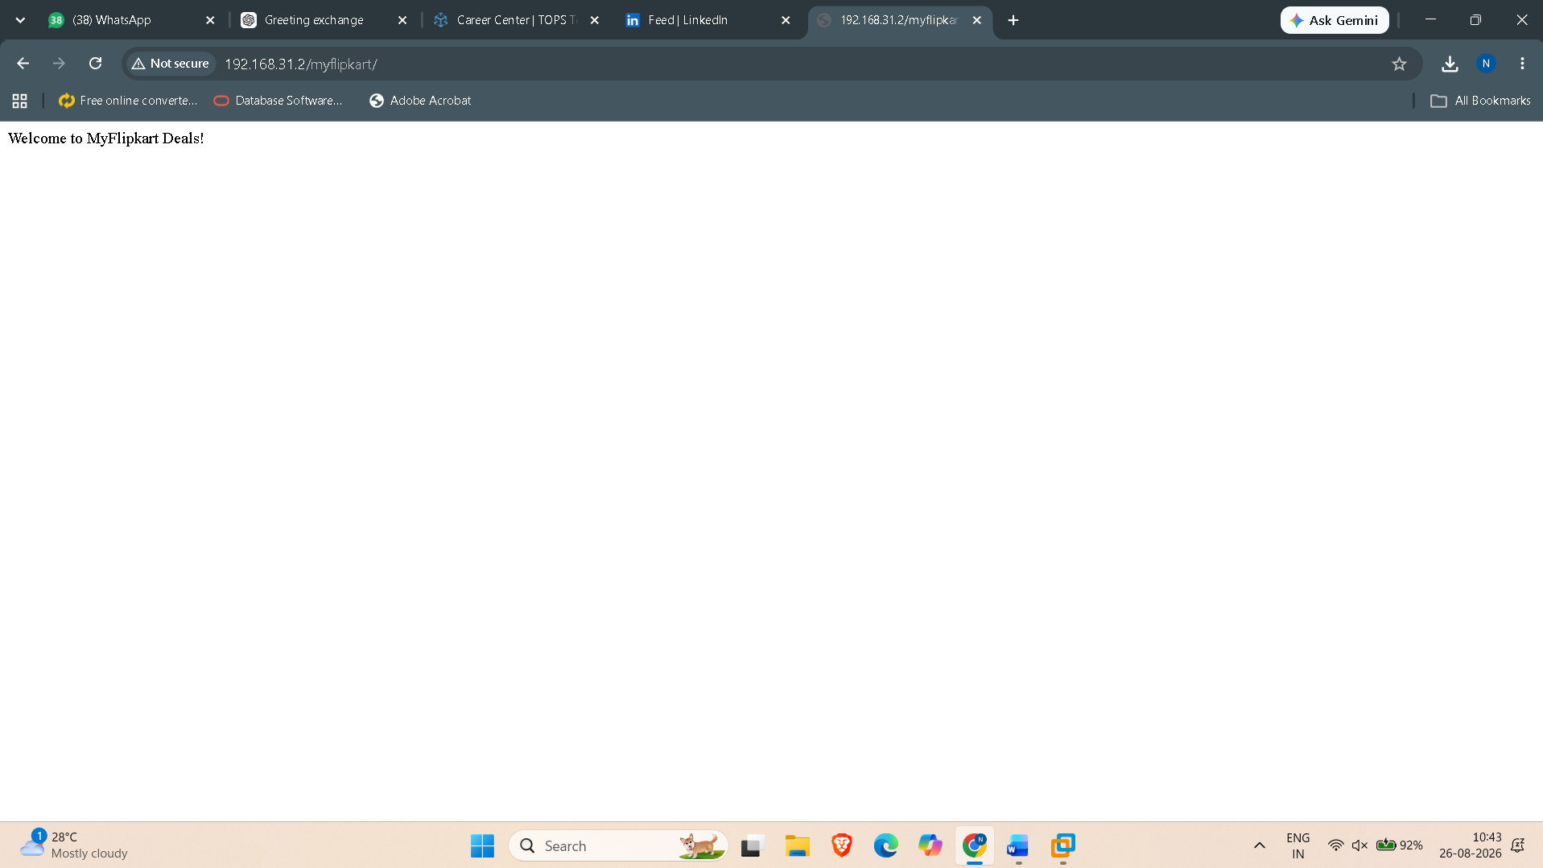

4. Add a favicon to your static site by placing a favicon.ico file in the correct location and updating your HTML to reference it. Use any small image and rename it to favicon.ico for this exercise.

ANS:

